**Clarity user Creation**

1. Set the environment and execute the below script
2. Enter the user name which we want to create

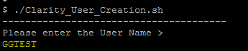

1. The script will automatically create the user account and grant all the requested privileges
2. Once the user account has been successfully created we will get a notification mail as mentioned below,

